***Creating S3 Event Notifications***

***Using an SNS Topic***

**Objective:**

Automate the notification process for specific events in an S3 bucket by integrating Amazon S3 with Amazon SNS.

Showcase expertise in AWS services and cloud automation through event-driven architecture.

**Services Integrated:**

Amazon S3: Store and manage data. Triggers event notifications when specific operations occur (e.g., object creation).

Amazon SNS: Distribute notifications to multiple subscribers in various formats like Email.

**Implementation Guide:**

**Step 1:** Create an S3 Bucket

Log in to the AWS Management Console.

Navigate to the S3 service.

Create a bucket and enable event notifications for operations like PUT, POST, or DELETE or All.

**Step 2:** Create an SNS Topic

Go to the SNS service in AWS.

Create a new topic (Event-notification-topic).

Add a subscription to the topic (parthsarthi.l2606@gmail.com).

**Step 3:** Modify the Access Policy for SNS

Update the SNS topic’s default access policy with the example policy from the [AWS Guide](https://docs.aws.amazon.com/AmazonS3/latest/userguide/ways-to-add-notification-config-to-bucket.html).

Ensure the policy allows S3 to publish notifications to the topic.

**Access Policy:**

{

"Version": "2012-10-17",

"Id": "example-ID",

"Statement": [

{

"Sid": "example-statement-ID",

"Effect": "Allow",

"Principal": {

"Service": "s3.amazonaws.com"

},

"Action": "SNS:Publish",

"Resource": "arn:aws:sns:us-east-1:307946662962:Event-notification-topic",

"Condition": {

"StringEquals": {

"aws:SourceAccount": "307946662962"

},

"ArnLike": {

"aws:SourceArn": "arn:aws:s3:::event-notification-s3-bucket-for-sns"

}

}

}

]

}

**Step 4:** Configure Event Notifications in S3

Go back to the S3 bucket(event-notification-s3-bucket-for-sns).

Add an event notification configuration with the SNS topic ARN.

**Step 5:** Testing the Setup

Upload or delete a file in the S3 bucket.

Verify the notification is received on the SNS subscription (e.g., email inbox).

# ***Topic Creation***

# ***Subscription Creation Setup***

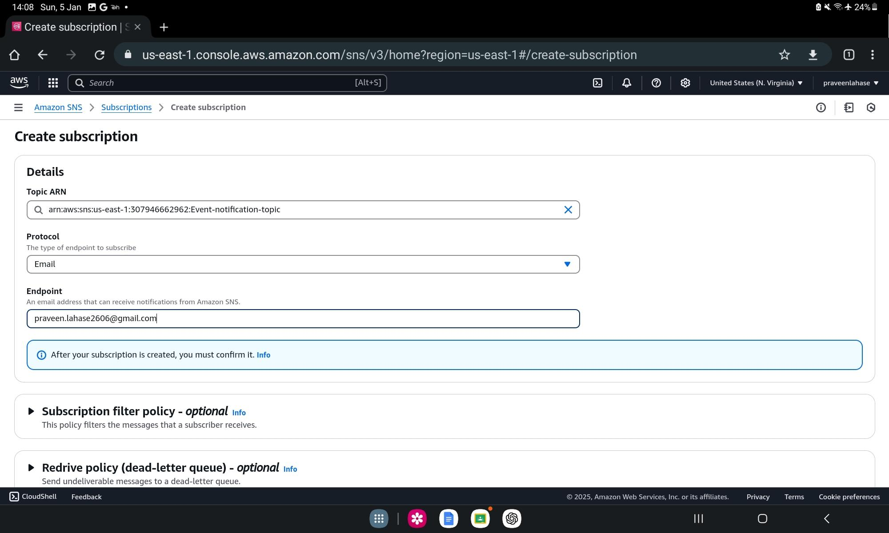

# ***Subscription Creation***

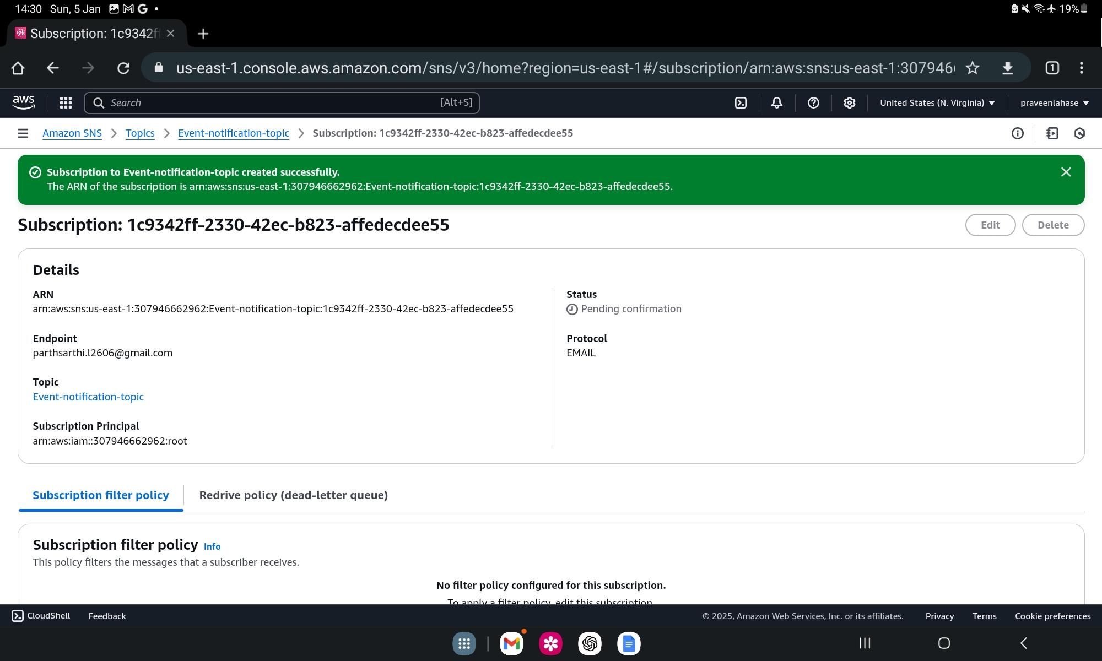

# ***Event Notification Creation***

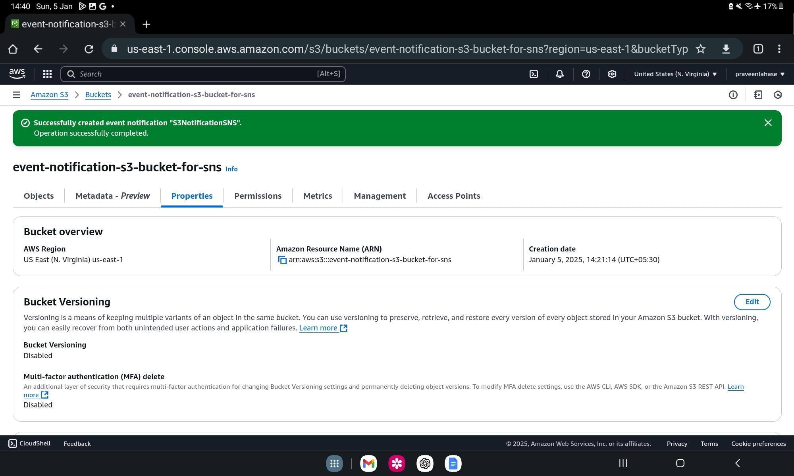

# ***Subscription Notification***

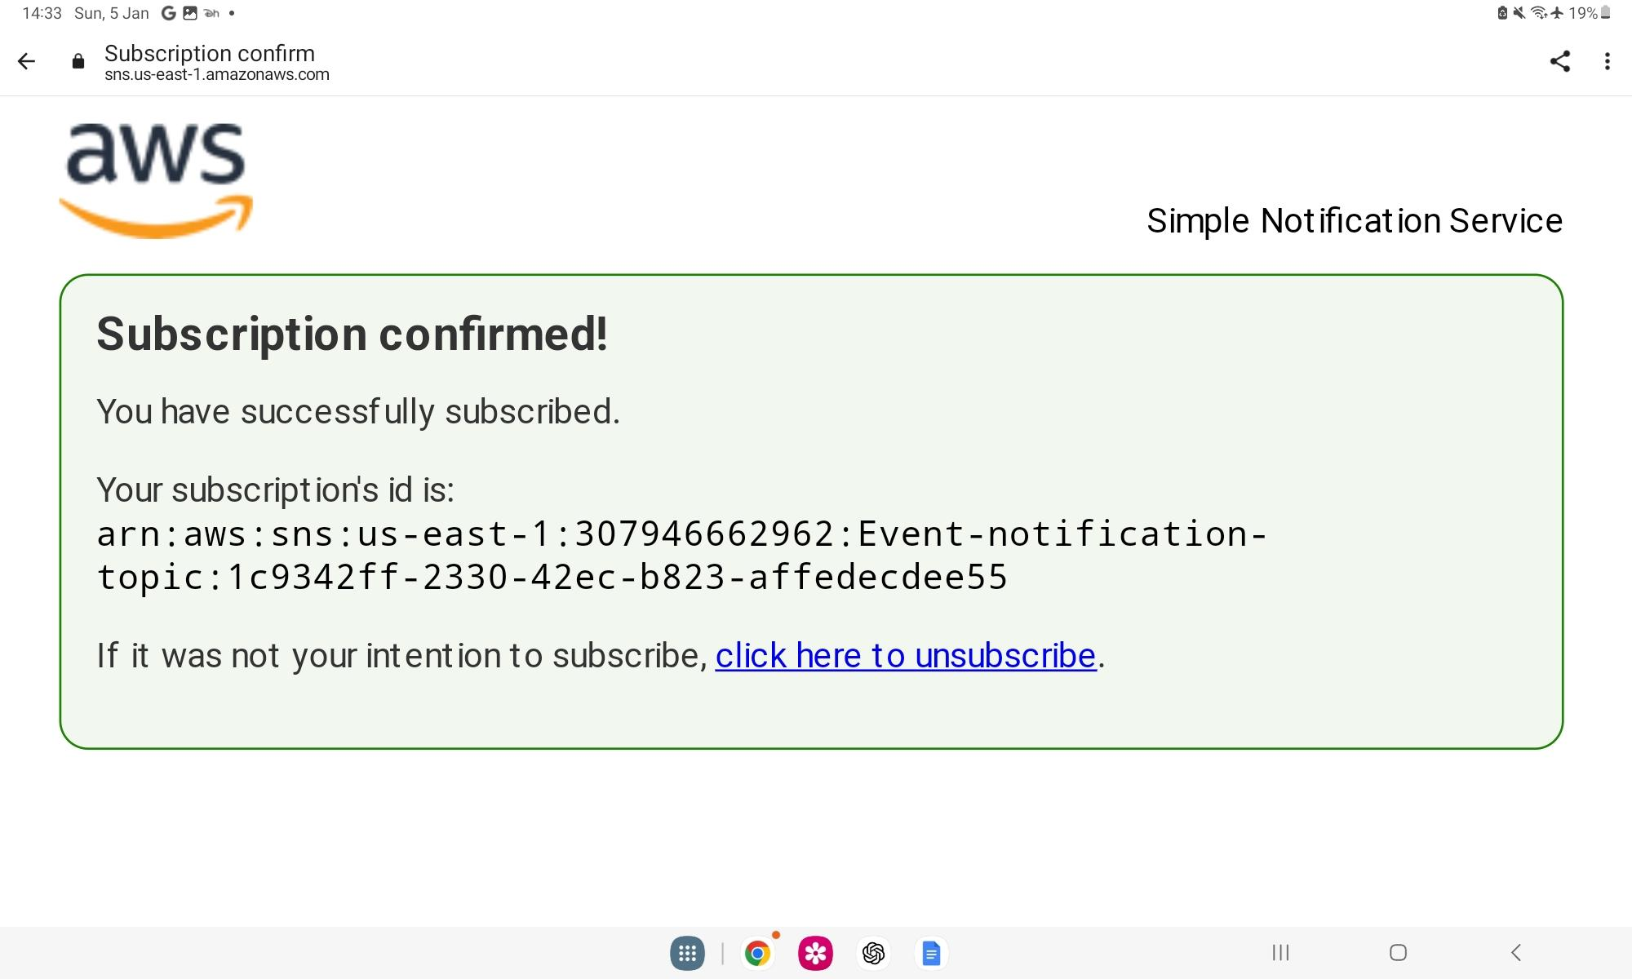

# ***Bucket Creation***

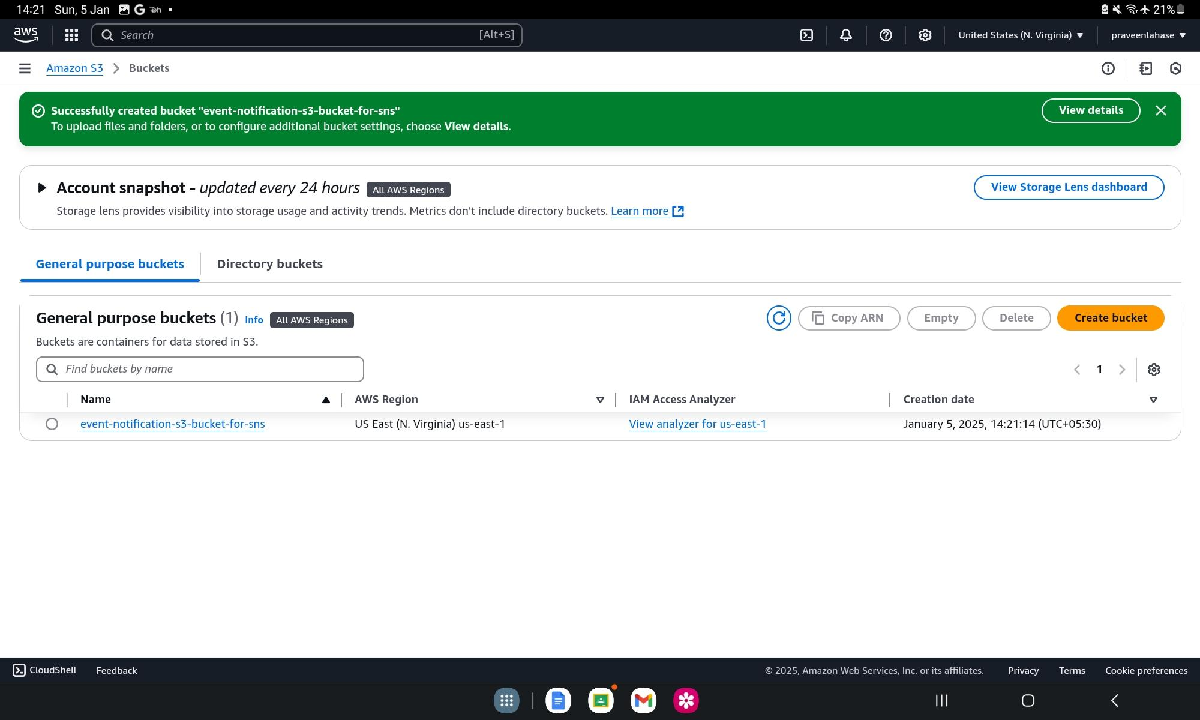

# ***File Upload to s3***

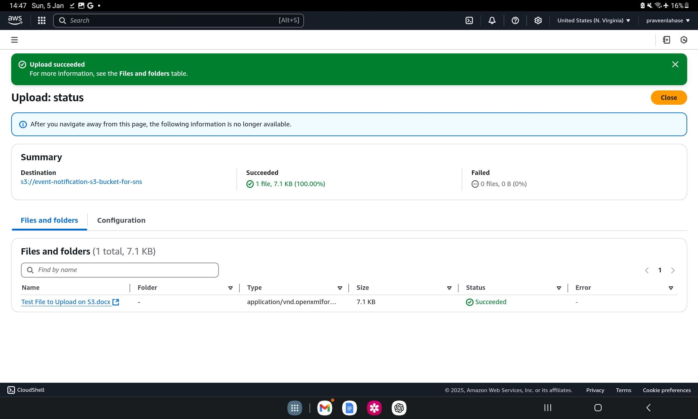

# ***AWS notification for file upload on s3***

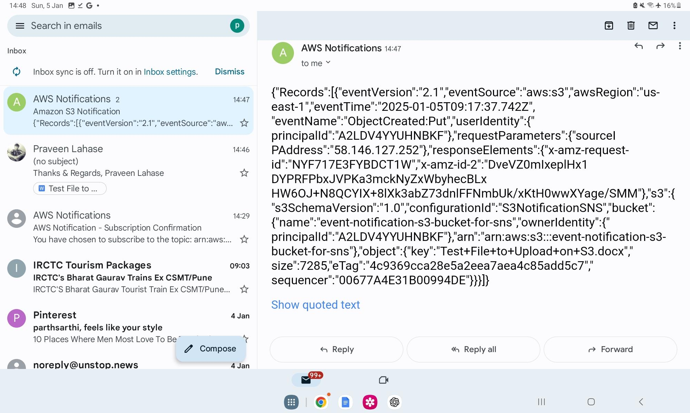

Thank you